IdeationPhase

DefinetheProblemStatements

|  |  |
| --- | --- |
| Date | 3 July 2025 |
| TeamID | LTVIP2025TMID60948 |
| ProjectName | Measuringthepulseofprosperity:anindexof  economicfreedom |
| MaximumMarks | 2 Marks |

**CustomerProblemStatementTemplate:**

Create a problem statement to understand your customer's point of view. The Customer Problem Statement template helps you focus on what matters to create experiences people will love.

A well-articulated customer problem statement allows you and your team to find the ideal solution for the challenges your customers face. Throughout the process, you’ll also be able to empathize with your customers, which helps you better understand how they perceive your product or service.

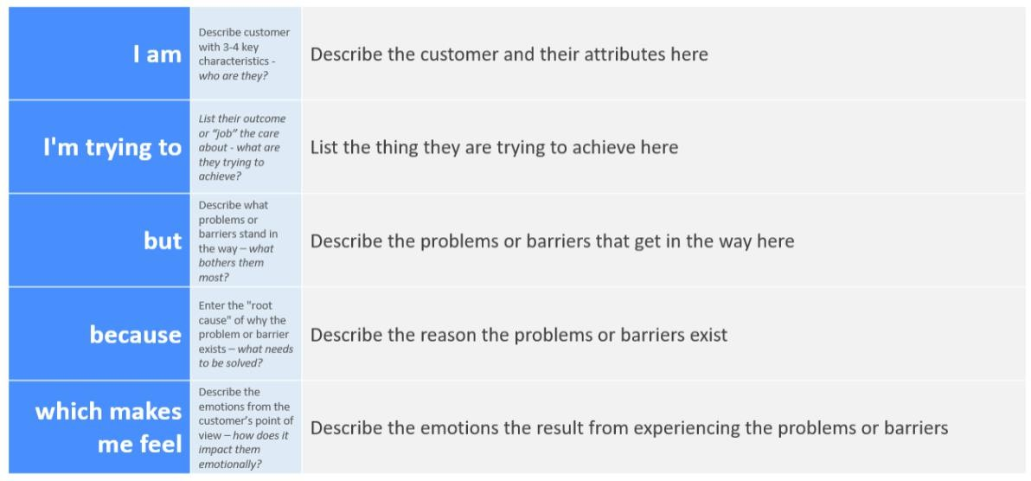

Reference:<https://miro.com/templates/customer-problem-statement/>

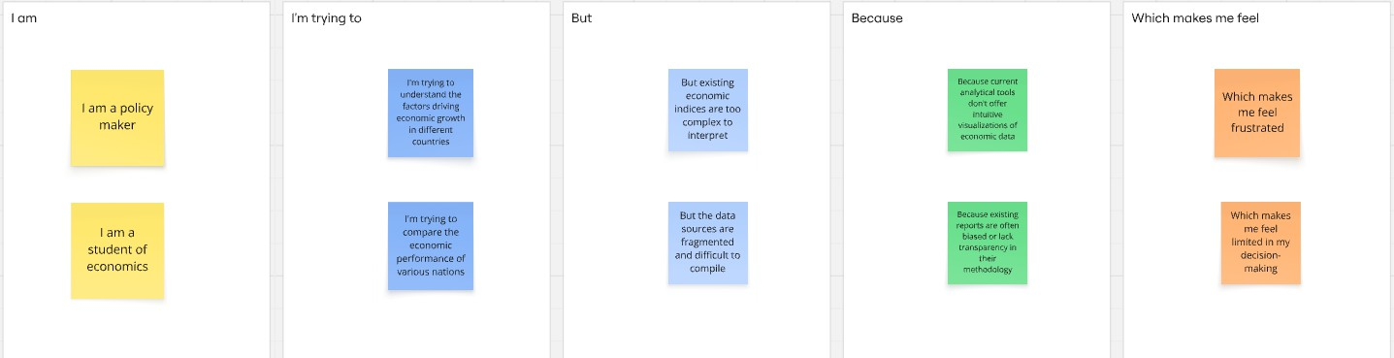

|  |  |  |  |  |  |
| --- | --- | --- | --- | --- | --- |
| **Problem Statement**  **(PS)** | **I am (Customer)** | **I’mtryingto** | **But** | **Because** | **Whichmakesme feel** |
| PS-1 | a policymaker | understand thedriversof economic prosperity in different nations to formulate effective policies. | existing economic indicesare often too complex, lacktimely updates. | there'saneedfor acomprehensive, easily digestible, and regularly updated index that integrates various dimensions of economic  freedom. | frustrated and uncertain about theoptimalpolicy choices. |
| PS-2 | an economic researcher | identifyclear correlations between economic freedom and socio- economic outcomesfor academic analysis. | currentdata sources are fragmented, inconsistent, and difficult to compare across different countries  andtime periods. | there isn't a standardized, reliable, and easily accessible dataset that combinesdiverse indicators of economic freedom with  relevantoutcome variables. | overwhelmed by data collection and analysis, and limitedindrawing robust conclusions. |

2.2Empathymap

